About Page Content

* Meet my professor – Would you like to find out more about your professor’s journey, and their pathway to becoming a science professor at Broward College? Attend one of our Meet my Professor events to learn more about your professor’s story, and ask questions to get to know them better. This is a series of events, featuring many different science professors and their academic journeys. Please join us in order to learn more about our wonderful Broward College science professors!

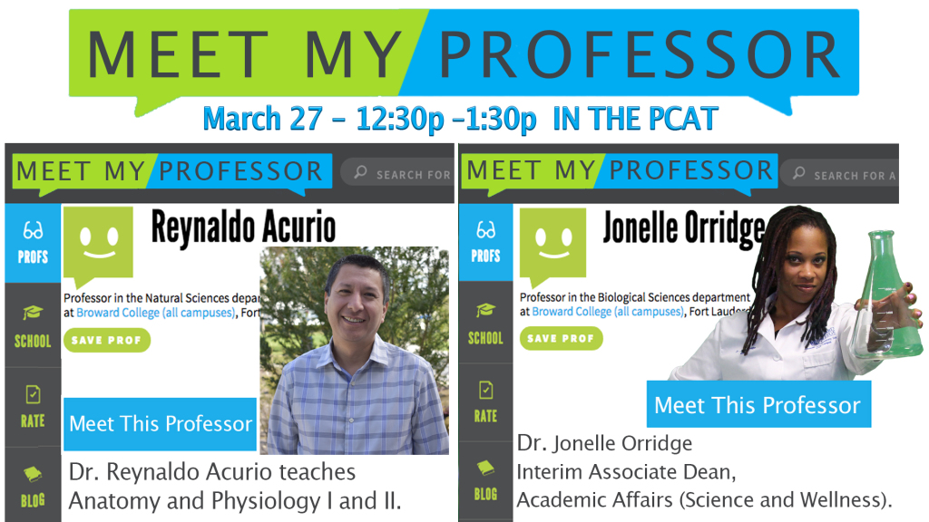

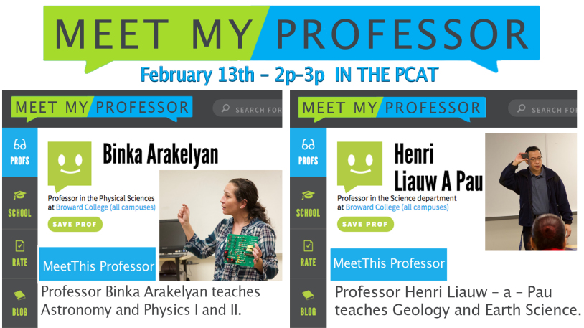

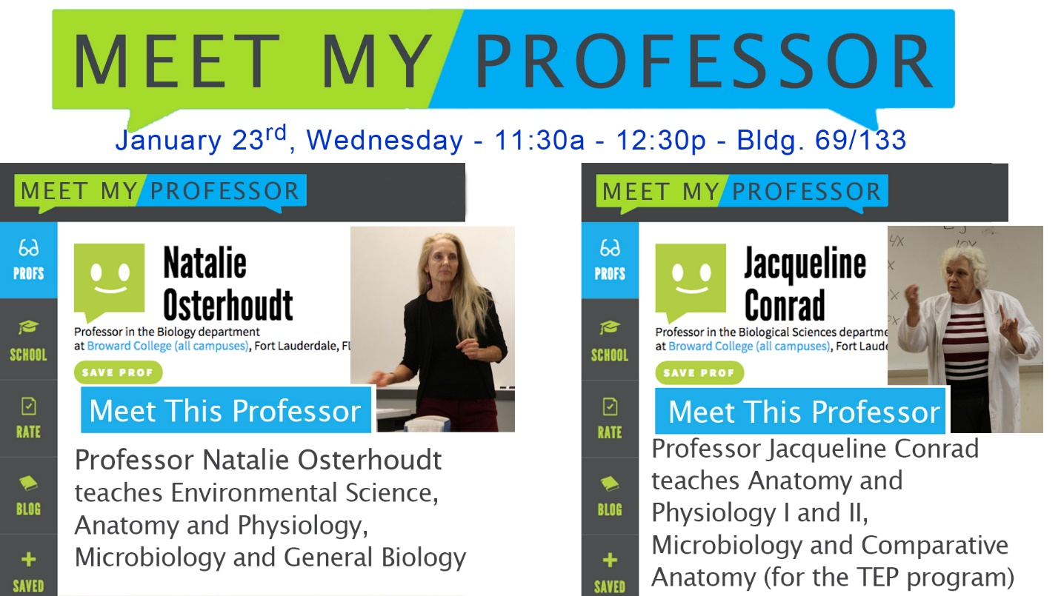

* Earth Day Science Fair –

Join us for BCSouth Earth Week, a week at Broward College South Campus that’s all about increasing awareness and appreciation of the natural environment. Earth Week has many fun and engaging events, including the Environmental Film Festival, Earth Week Science Fair, the Science Seminar Series South, Tree Planting and more! While you’re enjoying the various activities, you’ll also engage with your community, local government, and Broward College clubs and organizations. Explore your interest in Science, Technology, Engineering and Math (STEM) and get inspired.

Stay tuned to find out what activities are in store for Broward College South’s next Earth Week!

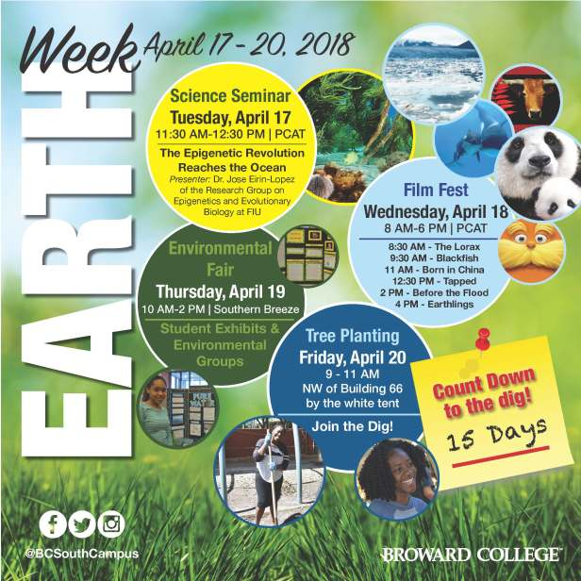

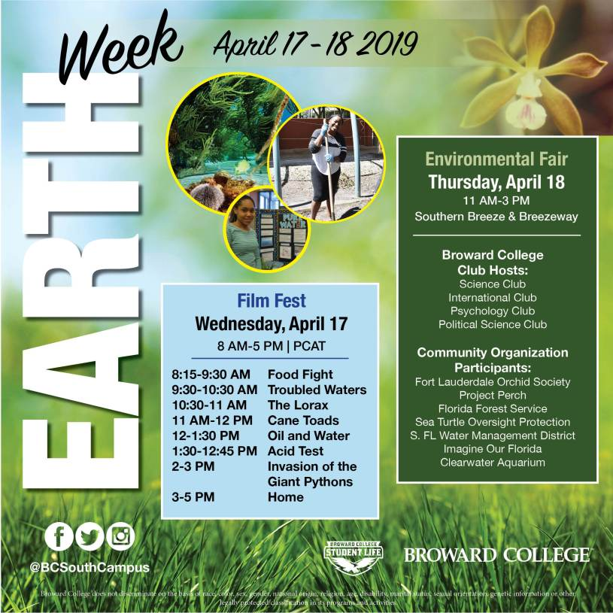

* <https://bcsouthcampus.com/2019/04/19/%f0%9f%8c%9ebcsouth-earth-week%f0%9f%8c%8f/> = link to pictures, video, etc. for Earth Week